CIS201 Fundamentals of web design

Project Documentation

Name: Youmna Jaza ID:201812214

1. An abstract design that specify the structure of the website using hand drawing.

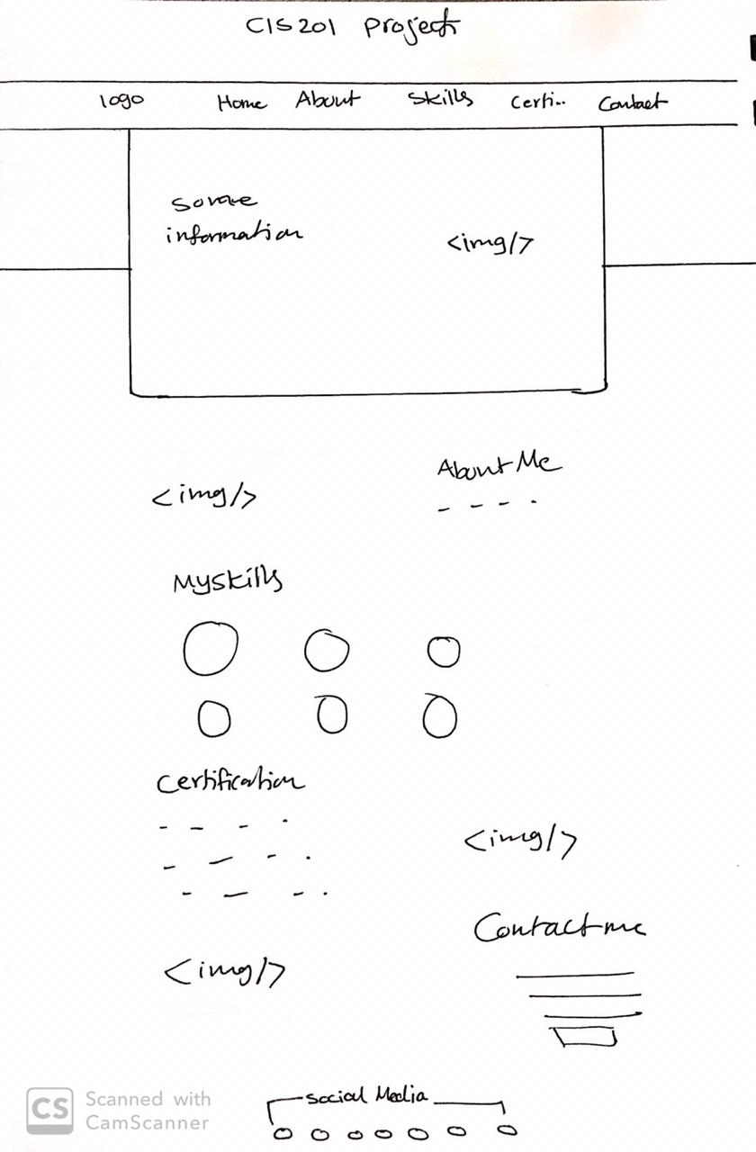

Navigation bar

Some image

A brief introduction

Detailed information about study and capabilities

Some image

Circles that show my level in each programing skills

Social media

Some image

Contact me form

Some image

List of certifications

1. 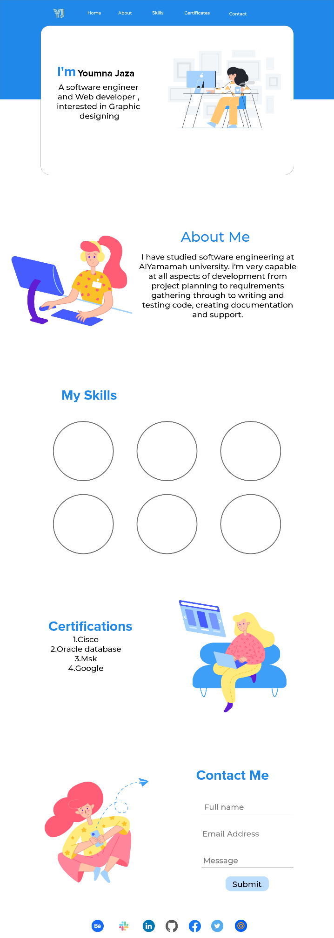A detailed design using Adobe Xd.

An image from by STREAMLINE

An image from by STREAMLINE

An image from by STREAMLINE

Circles that show my level in each programing skills

Font-family: Proxima Nova

Font-family: Montserrat

An image from Unruly Landing Page Illustrations with changing some colors using Adobe illustration

Logo

Color: #1F88E9